Collision Detection

Step 1 – Make movement by arrow keys ( keyboard key detection)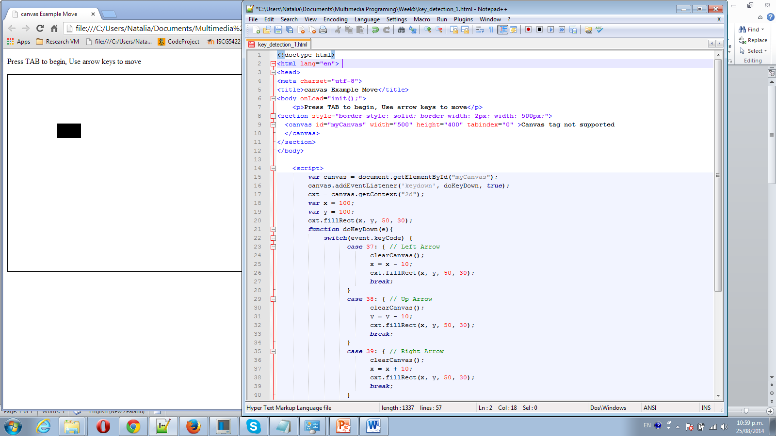

We use:

var canvas = document.getElementById("myCanvas");

canvas.addEventListener('keydown', doKeyDown, true);

every time we “move” our object – we actually re-draw it in new place

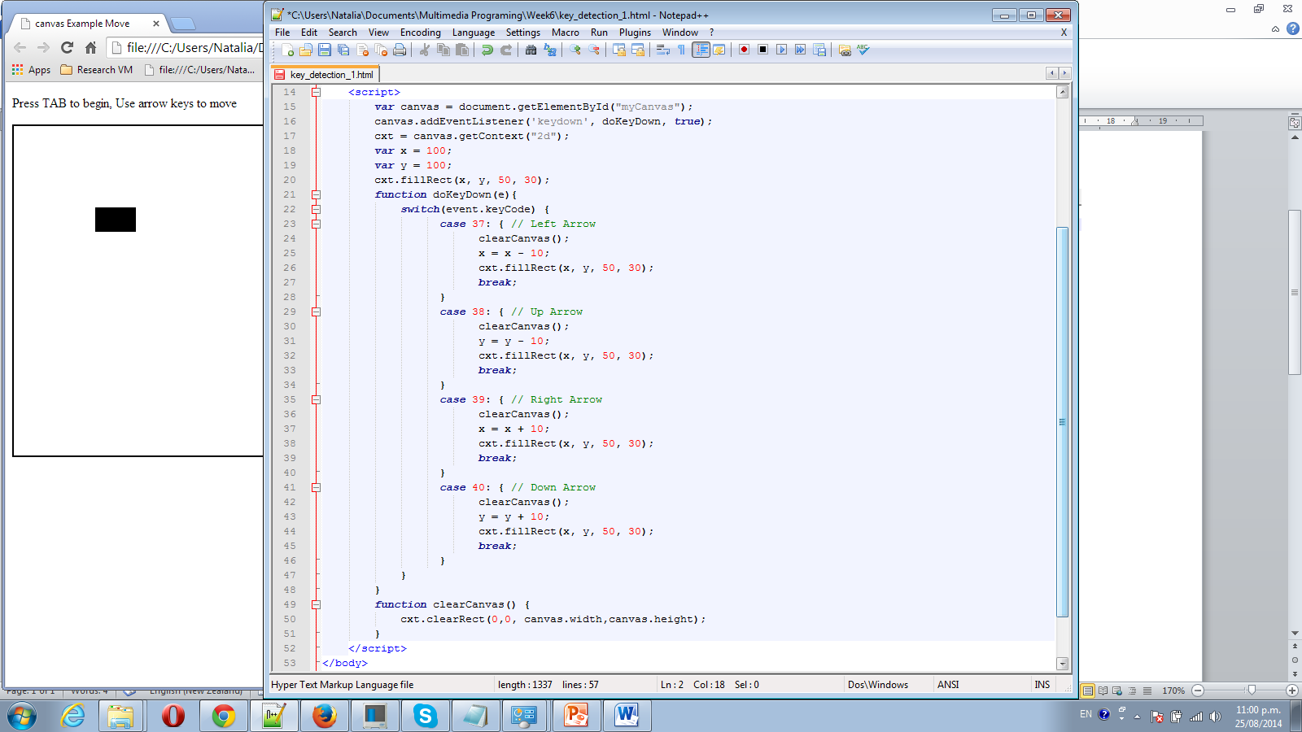

Step 2 - We add 3 static pink rectangular, We will need to re-draw them as well on each move. function updateCanvas() {

cxt.clearRect(0,0, canvas.width,canvas.height);

cxt.fillStyle="#FF00FF";

cxt.fillRect(x1, y1, 30, 30);

cxt.fillRect(x2, y2, 30, 30);

cxt.fillRect(x3, y3, 30, 30); }

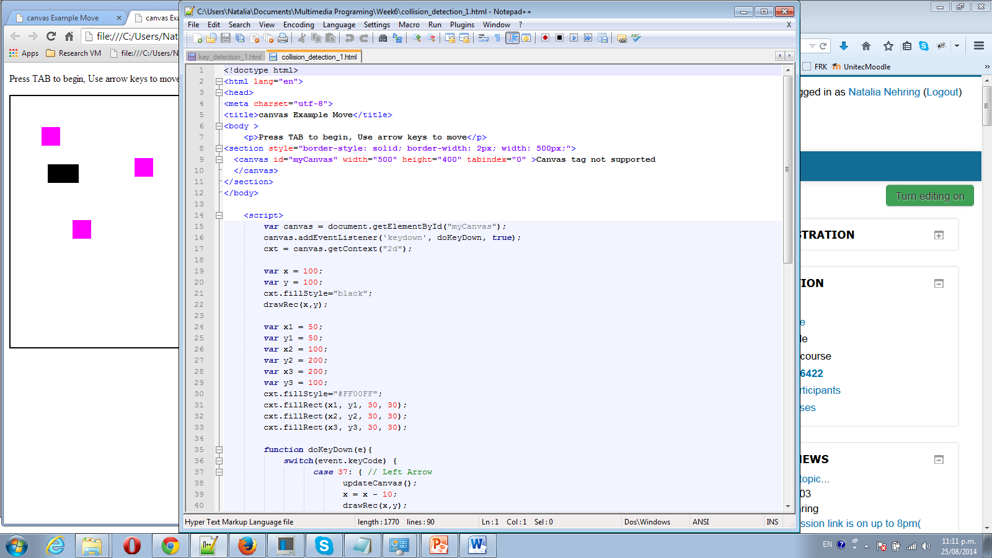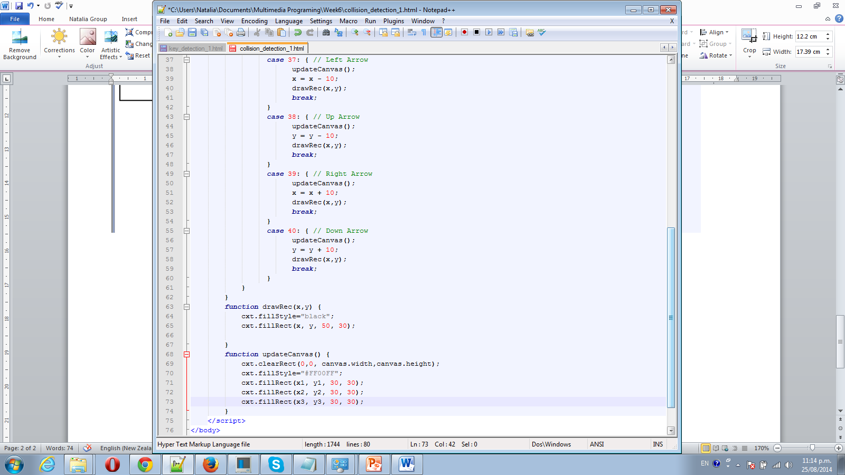

Step 3 We need to put our 3 boxes data in Array:

var box1=[x1, y1, 30, 30];

var box2=[x2, y2, 30, 30];

var box3=[x3, y3, 30, 30];

//var boxs = [box1,box2, box3]; // possible way to declare array as well

var boxs = []; // declare array

boxs.push(box1); // add element to array

boxs.push(box2);

boxs.push(box3);

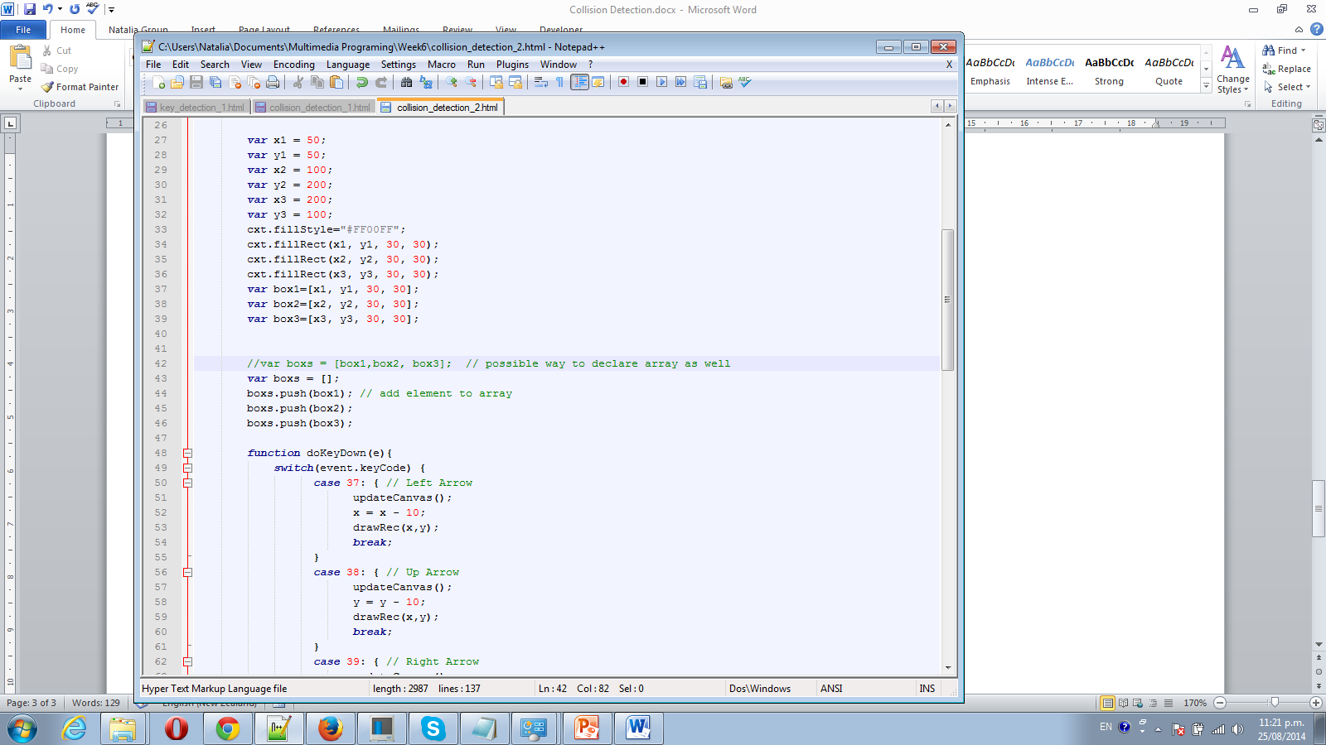

We use function check(x, y, w, h); - to check our black rectangular does it touch any others (pink) rectangular on canvas:

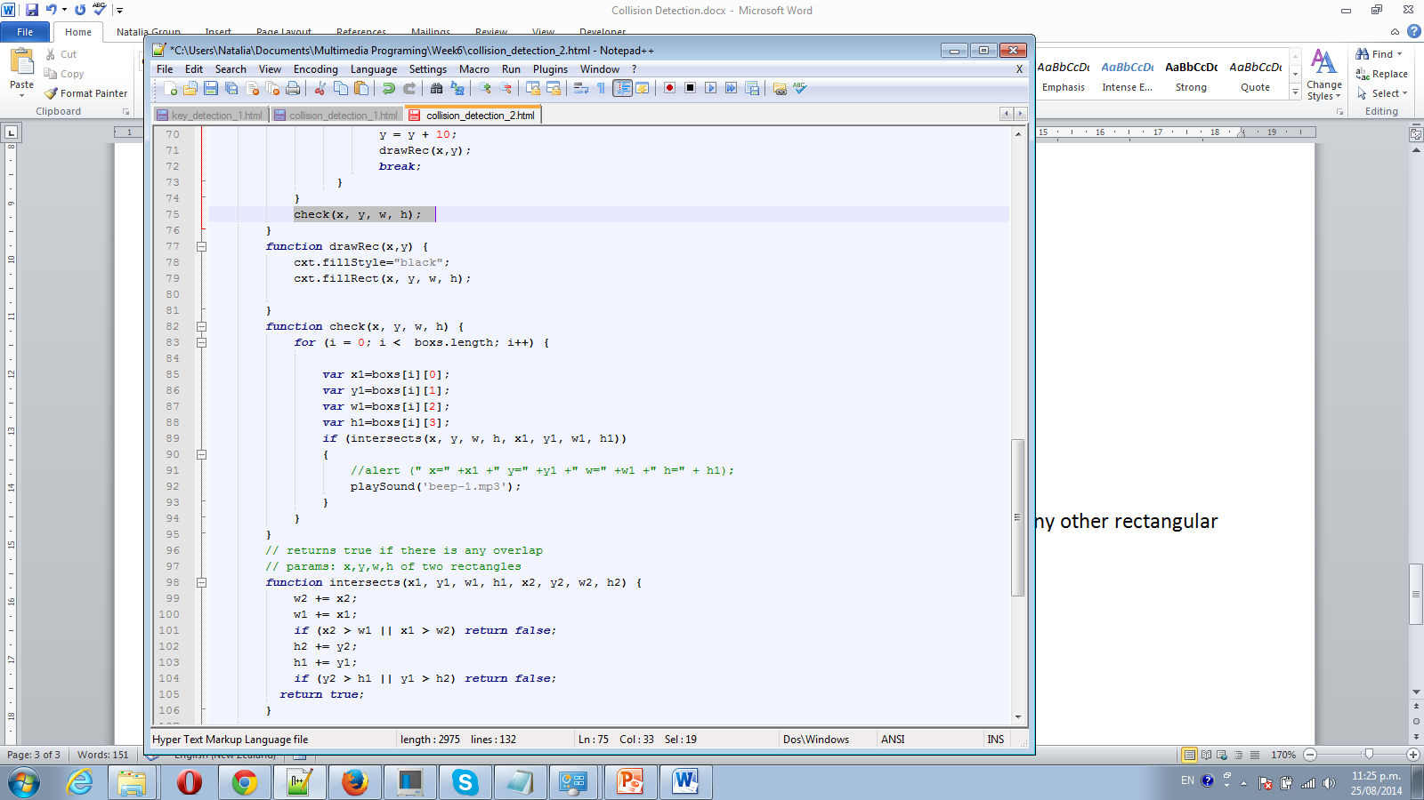

Add sound – we need to put sound file beep-1.mp3 in same directory as your html file.

* In your html file inside<body> tag add *<span id="dummy"></span>*
* In your java-script add :

function playSound(soundfile)

{

document.getElementById("dummy").innerHTML=

"<embed src=\""+soundfile+"\" hidden=\"true\" autostart=\"true\" loop=\"false\" />";

}

* Add function call:

playSound('beep-1.mp3');

Test your file.

Step 4 Add score and remove pink box!

Declare variable: var sc=0;

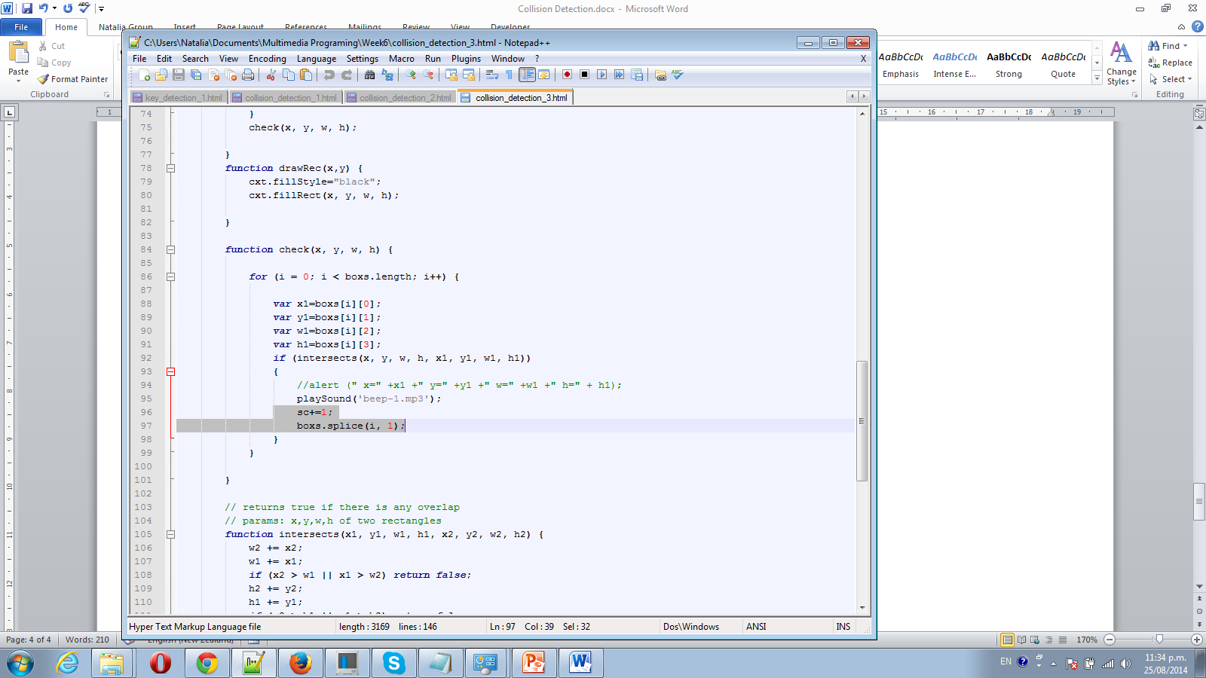

Use function boxs.splice(i, 1); - to remove box, if we touch it.

Change UpdateCanvas function, to make it more universal

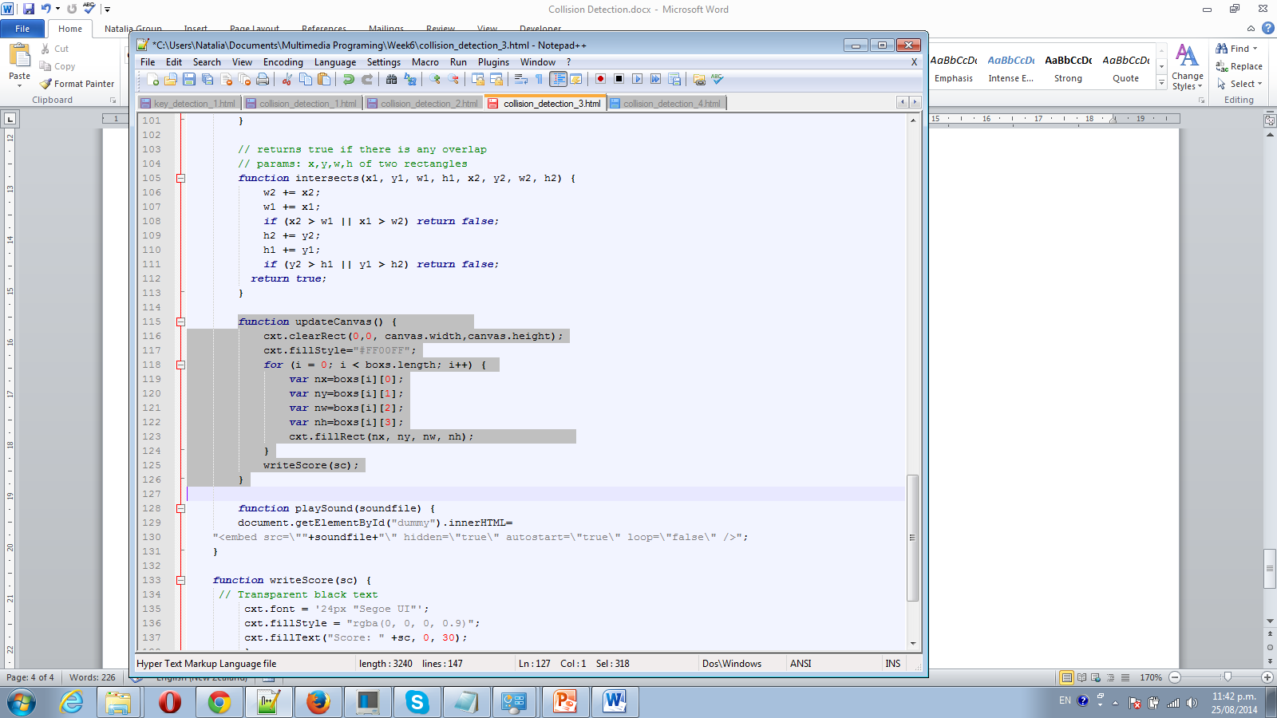

Step 5 Add more objects to canvas and make them move:

//Check if we should generate a new Rectangle to start move

if (Math.random() < 0.09)

{

nx = -10;

ny = Math.floor(Math.random() \* canvas.height);

boxs.push([nx, ny, 30, 30]);

}

